Task manager documentation

## Home

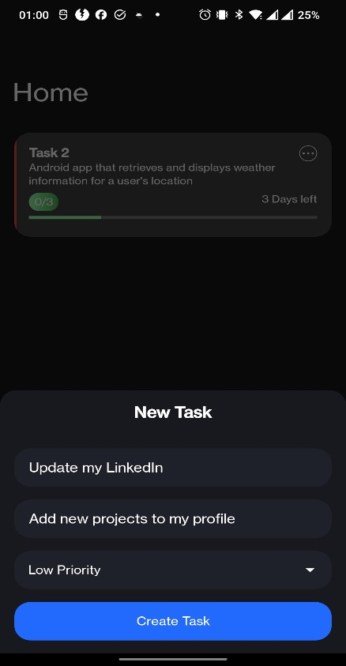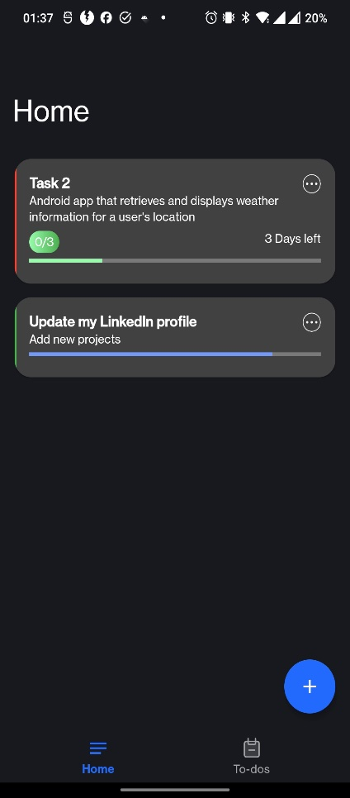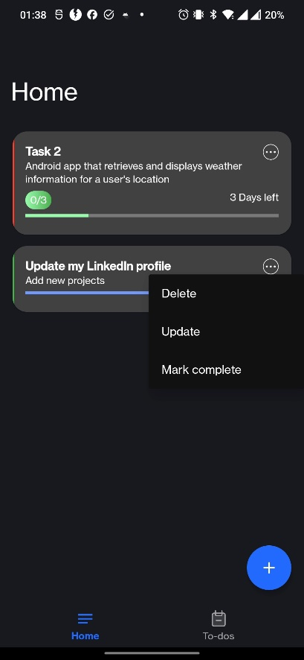

Allows user to edit or delete each task

Opens window to help add new task’s

The color change on the side shows task’s priority

Each task on click will open more detailed screen with its sub-tasks/to dos

## Todo

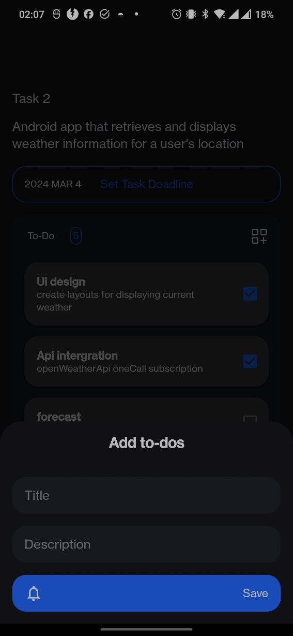

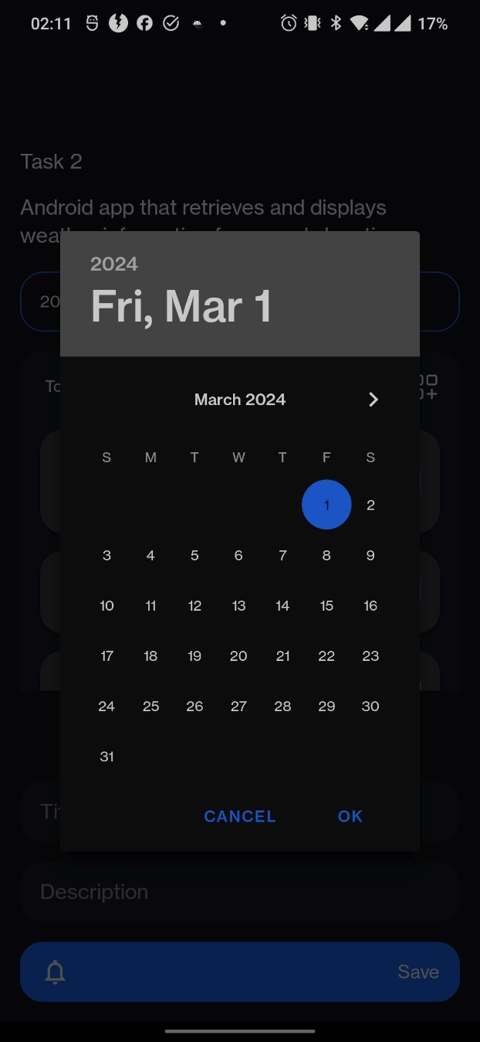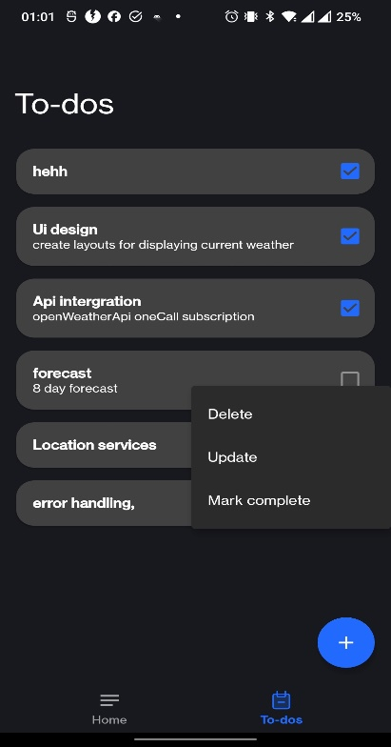

Long clicking each to-do item will give you options to manage your to dos

## Task details screen